Washington, D.C. Political Science Study Away- Fall 2023
Travel Dates: December 9-13, 2023 (Saturday-Wednesday)

Political science students are invited to participate with the Honors students in a study away to Washington, D.C., December 9-13, 2023. The Honors Program sponsored the successful experience in December 2017 and decided to open it for political science students in 2018.

Eligibility:
- Students must have a cumulative 3.00 GPA or higher;
- sophomore status or higher;
- 6 earned hours of political science courses, including PSC 100 (must have a C or better in these courses); and
- enrollment in one 3-hour political science course during Fall 2023 semester (all courses must be at JSU).

Enrollment Process: All students who participate will need to enroll in the 1-hour Political Science Study Away course (PSC 398) for the Fall 2023 term.
If you are interested in the study away, complete and submit the application by July 1, 2023. A $200 deposit made payable to JSU is due two days after your application is submitted. This $200 deposit goes toward the final total of the pre-paid items.
Class Meetings: The PSC 398 1-hour course will be a hybrid course, which means we will meet in class some weeks and you will complete outside work related to the class during other weeks. If you are a PSC major or minor, this course will count toward hours in your major or minor and toward required graduation hours. The class will meet on select Monday at 4:30 p.m.
This itinerary is a draft and is subject to some modification depending on weather and schedule conflicts, but it will give you a good idea of the things we will enjoy while we are in D.C. However, we will build the final itinerary of the course throughout the Fall 2023 semester. It is not likely that you will see everything you want to during our time in D.C. (there is just too much to see in 4 days!!!) but everyone should be able to mark several major museums and other attractions off their bucket list. Washington is beautiful during the Christmas Season!
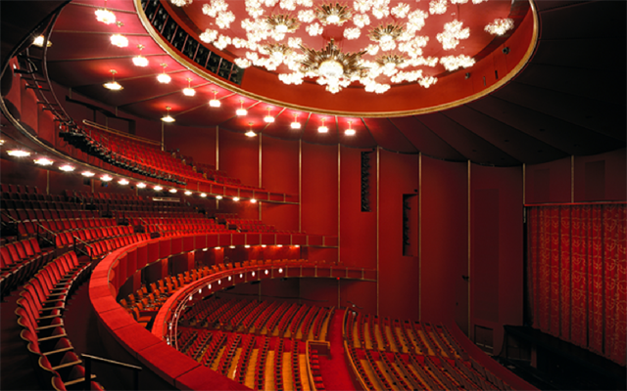
Highlights of the Experience:
Itinerary Possibilities: Library of Congress, National Portrait Gallery, National Museum of American Art, John F. Kennedy Center for the Performing Arts, The National Christmas Tree and 50 state trees and US Territories, and Old Town Alexandria. Our Congressman, Mike Rogers, can request White House passes for our group and we must make that request with names and social security numbers 90 days in advance since the Secret Service will have to conduct a background check. The White House Tour is subject to modification and cancellation depending on circumstances.
Other potential destinations which will be decided by the class and instructor include:
*Private tour of US Capitol Building by Congressman Mike Rogers' office. Congressman Rogers is the U.S. Representative for the Third Congressional District and a JSU Alum.
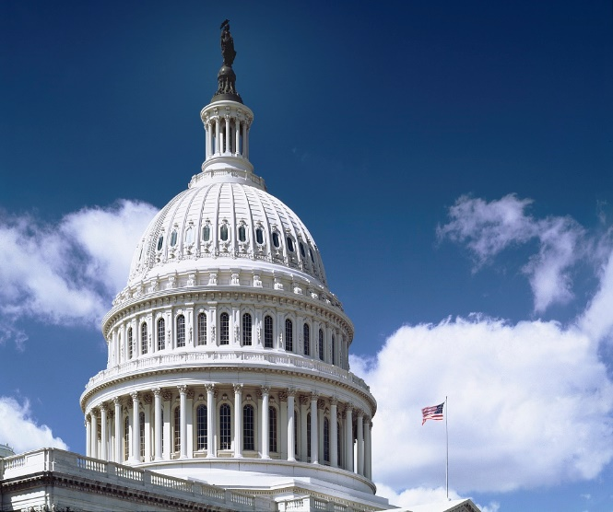
*Smithsonian Museums (museums are free; admission might be charged for some special exhibits or for IMAX films but those are optional).
National Museum of American History
National Museum of Natural History
National Air and Space Museum
National Holocaust Museum
National Archives
National Museum of the American Indian
National Museum of African American
History and Culture
There are several additional art museums and galleries, but the ones listed above appeal to a wider audience.
*Various Monuments on the National Mall
Ford’s Theatre
Museum of the Bible- Admission charge currently $19.99 for students
National Cathedral – Cost: $8 per person for self-guided tour (Mon-Fri). Attending Sunday services is free (11:15 a.m. to 12:45 p.m. or Choral Evensong 4:00 to 5:00 p.m. Weekday Evensong is Mon-Thu 5:30 to 6:15 p.m.).
*Tour of Arlington National Cemetery and Tomb of the Unknown Soldier, and Kennedy gravesites. If you have relatives buried at Arlington, this would be a good opportunity to visit their graves. Cost for Tram Tours: $19.50 per person.
The John F. Kennedy Center for Performing Arts- Students have the option of purchasing tickets to a scheduled performance. Free concerts are also available each evening in the Millennium Theatre.
Pre-paid Expenses: Hotel in Old Town Alexandria, VA and round-trip Flights from Atlanta to D.C.: $916 per person. This price is 2 people per room with standard beds and includes taxes and full breakfast for 4 nights/days. We have figured flights on the high end ($500) and checking a bag on the departure and return flights. We will monitor flight prices throughout the semester and buy at the best rate. Students should realize flight prices are subject to change depending on world events. Airline ticket prices are currently elevated due to higher gas prices. All rooms will have a microwave and small refrigerator.
Single occupancy and flight $1,332.00 per person (includes baggage fees, taxes, and full breakfast).
Triple occupancy (3 per room) and flight $778 per person (includes baggage fees, taxes, and full breakfast).
Quadruple occupancy (4 per room) and flight $708 per person (includes baggage fees, taxes, and full breakfast).

Additional Expenses while in D.C.:
Lunch and Dinner: There is a Whole Foods full-service grocery store that has a deli with soup and salad bar near the hotel, so students may choose to eat on a smaller budget for dinner and spend their money on souvenirs or other items. We will be in the heart of D.C., the Beltway, for lunch each day, which is why we want you to take advantage of the full breakfast, so you will not have to spend as much on lunch. You should figure on $10-$15 for lunch each day, so $50-$75 total for 5 days. You may purchase food items from the grocery store for dinner or dine in one of the local restaurants near our hotel. Price range for dinners will be $10-$25 per day, so plan for $30-$125 total for dinners. Food price range for 4 days/5 nights is $100-$200.
Metro Card: We will be traveling on foot and by metro (which is very clean and safe) and you will purchase a metro card when we arrive. A 7-day metro pass is available for $38-$58 or you can add value to your metro card each day before we board. There is a $2 initial fee to purchase the smart metro card, which operates like a debit card when riding the metro.
Miscellaneous Uber or Lyft: $30
Souvenirs: $75-$150
Enrollment and Class Registration: Students should complete and submit the required paperwork no later than July 1, 2023.
Rooms will be assigned by gender. If you wish to share a room, it is your responsibility to secure the number of students you want to have in your room (double, triple, or quadruple occupancy).
Space is limited for this study away so apply and enroll early.
Fundraising: The class might wish to hold one or more fundraisers during the term to lower the cost of the trip.
Enrollment in PSC 398: Students will be allowed to enroll in the study course after paying the $200 deposit.
Contact Dr. Lori Owens at (256)782-8269 for additional information or email Dr. Lori Owens, professor of Political Science, who will serve as the Washington, D.C. group leader and instructor for the PSC 398 course, at ljowens@jsu.edu.

Payment Schedule:
July 1st Application and $200 deposit due
October 1st 50% of remaining balance due for all students
November 1st Remaining balance due for all students

